A

Project Report

is

Submitted to the completion of Epam-COE-DevOPS

Training Program



Submitted By:

Ms. Priyanka Bhardwaj

Junior Software Engineer-Epam Hyderabad

**Task-1 ( Three Tier web application using docker and Kubernetes )**

1. Install kubectl

2. curl -LO <https://storage.googleapis.com/kubernetes-release/release/$(curl> -s <https://storage.googleapis.com/kubernetes-release/release/stable.txt)/bin/linux/amd64/kubectl>

3. chmod +x ./kubectl

sudo mv ./kubectl /usr/local/bin/kubectl

4. Create an IAM user/role with Route53, EC2, IAM and S3 full access

5. Attach IAM role to ubuntu server

Note: If you create IAM user with programmatic access then provide Access keys.

aws configure

6. Install kops on ubuntu instance:

7. curl -LO <https://github.com/kubernetes/kops/releases/download/$(curl> -s <https://api.github.com/repos/kubernetes/kops/releases/latest> | grep tag_name | cut -d '"' -f 4)/kops-linux-amd64

8. chmod +x kops-linux-amd64

sudo mv kops-linux-amd64 /usr/local/bin/kops

9. Create a Route53 private hosted zone (you can create Public hosted zone if you have a domain)

10. create an S3 bucket

aws s3 mb s3://dev.k8s.priya.in

11. Expose environment variable:

export KOPS_STATE_STORE=s3://dev.k8s.priya.in

12. Create sshkeys before creating cluster

ssh-keygen

13. Create kubernetes cluster definitions on S3 bucket

kops create cluster --cloud=aws --zones=us-east-1d --name=dev.k8s.priya.in --dns-zone=priya.in --dns private

14. Create kubernetes cluster

kops update cluster dev.k8s.priya.in --yes

15. Validate your cluster

kops validate cluster

16. To list nodes

kubectl get nodes

**….......................................................................**

1. Login to AWS

2. Create Roles: KubernetesIAM

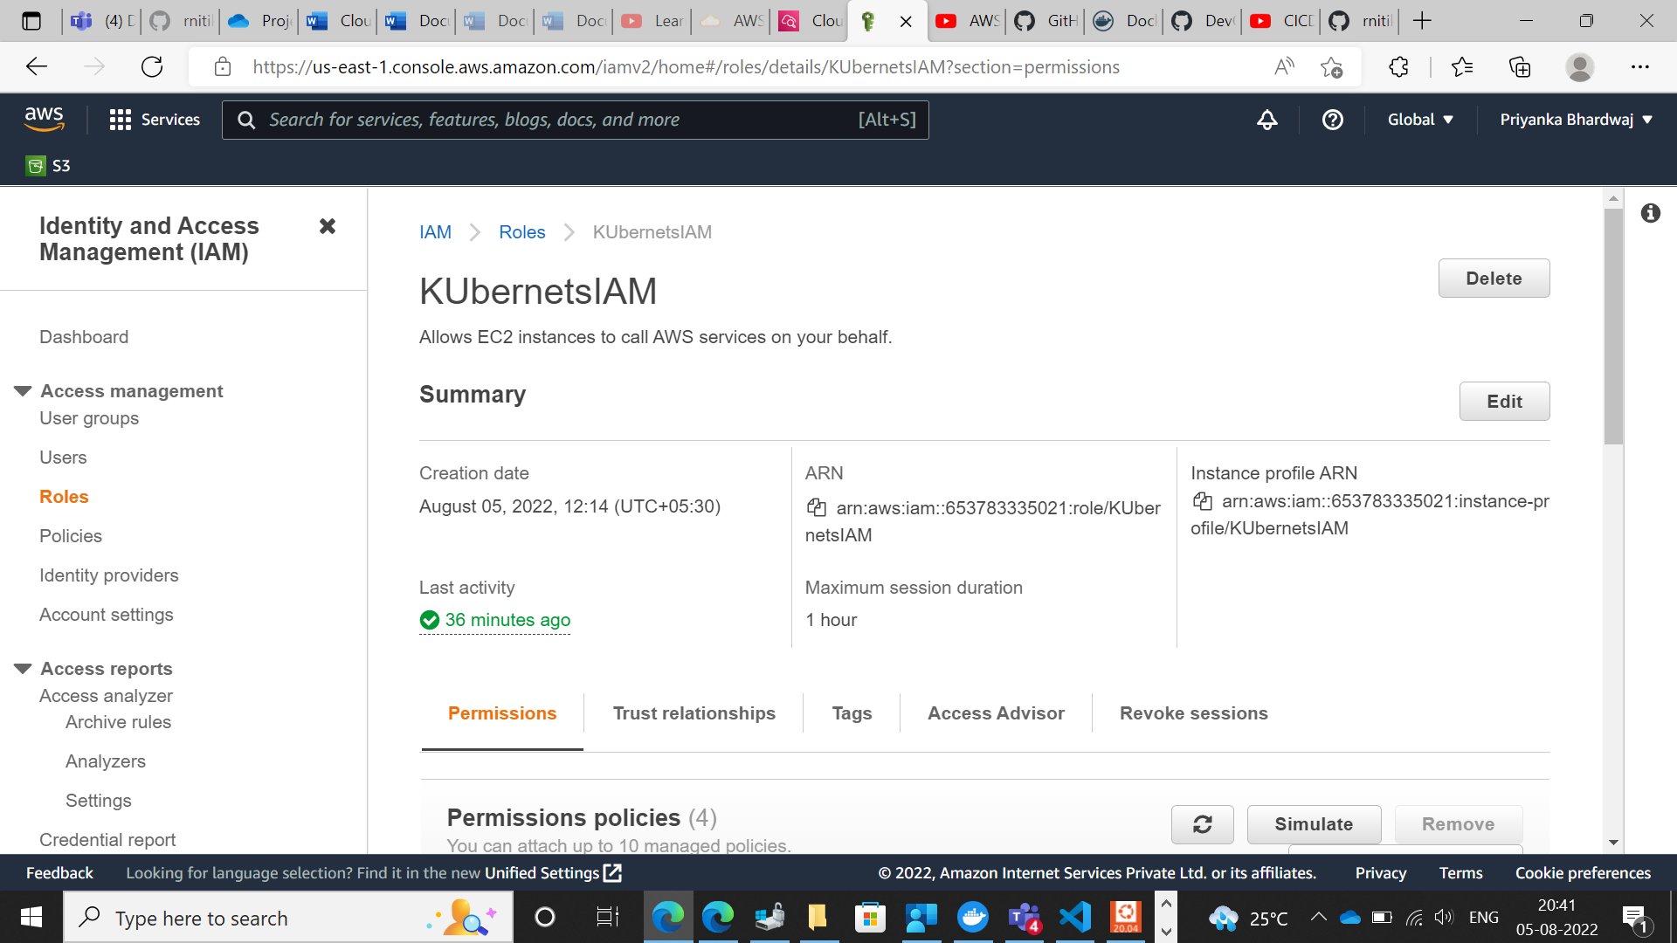

3. Assign policies to role

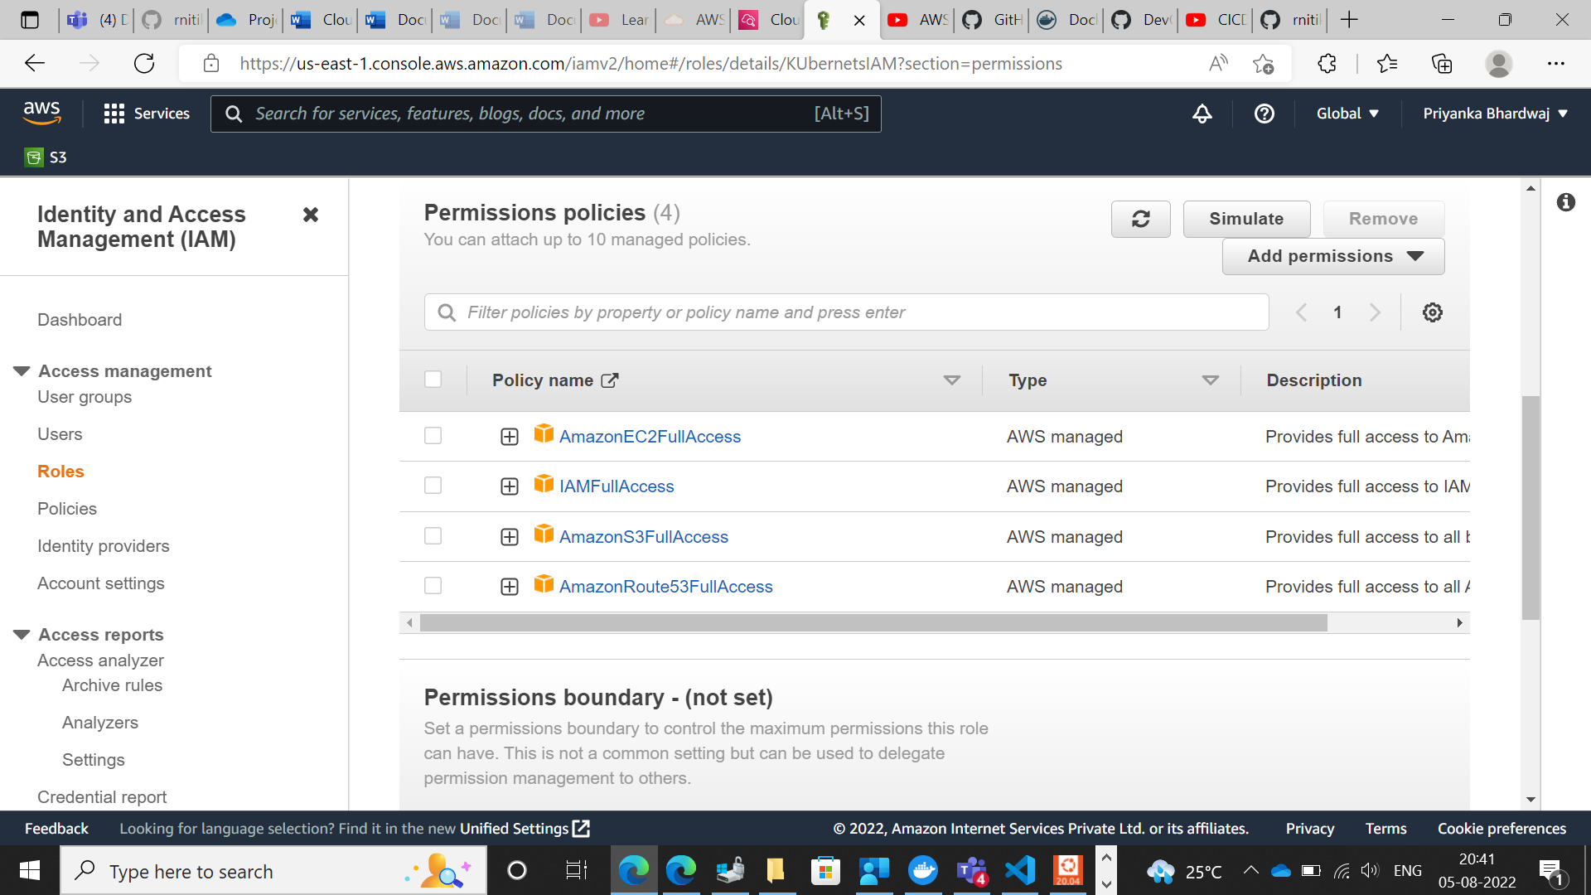

4. Create EC-2 instance

A) Named Controller-VM

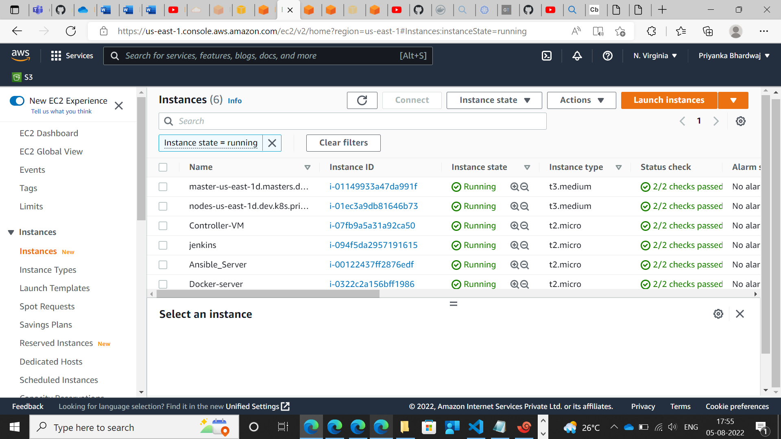

b) Assigned IAM Role to Controller-VM

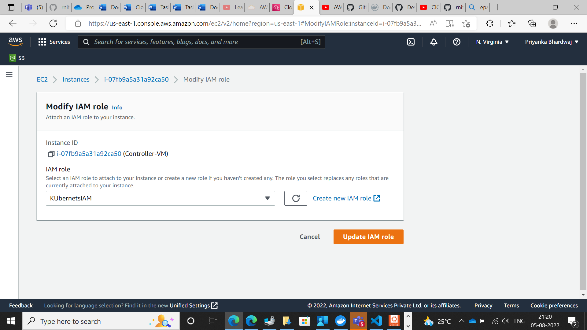

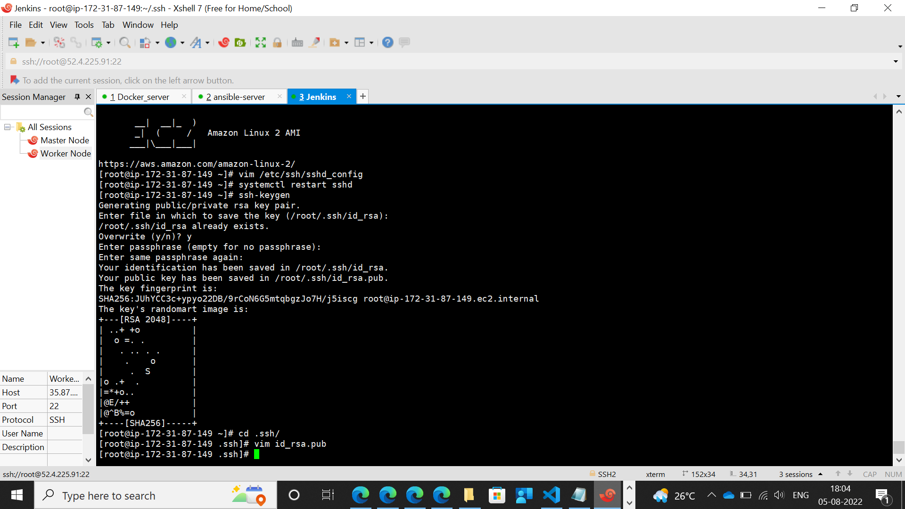

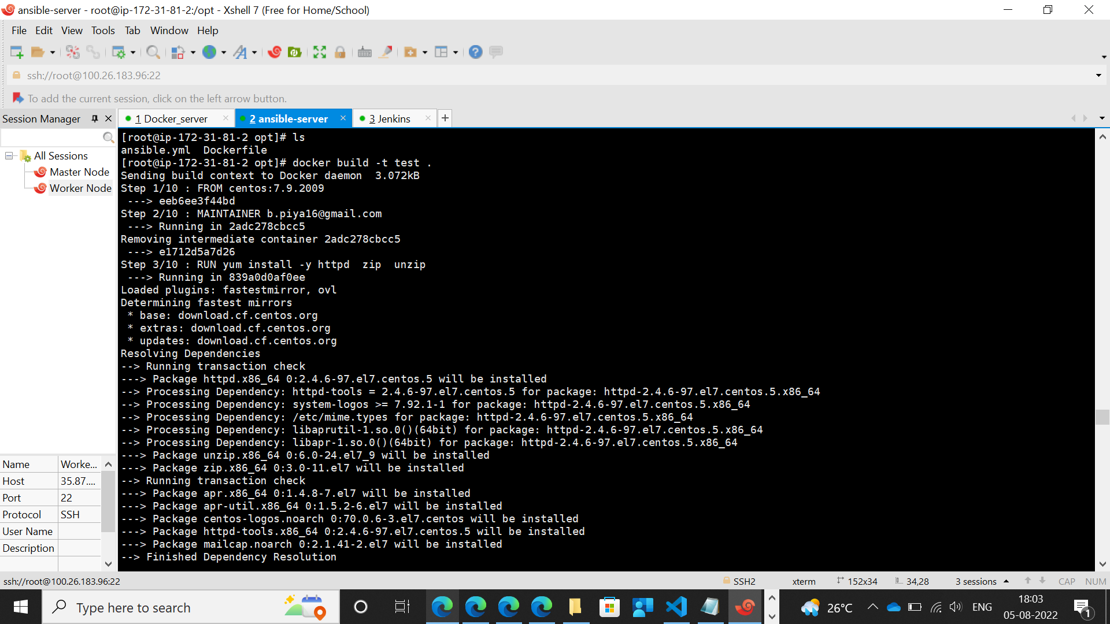

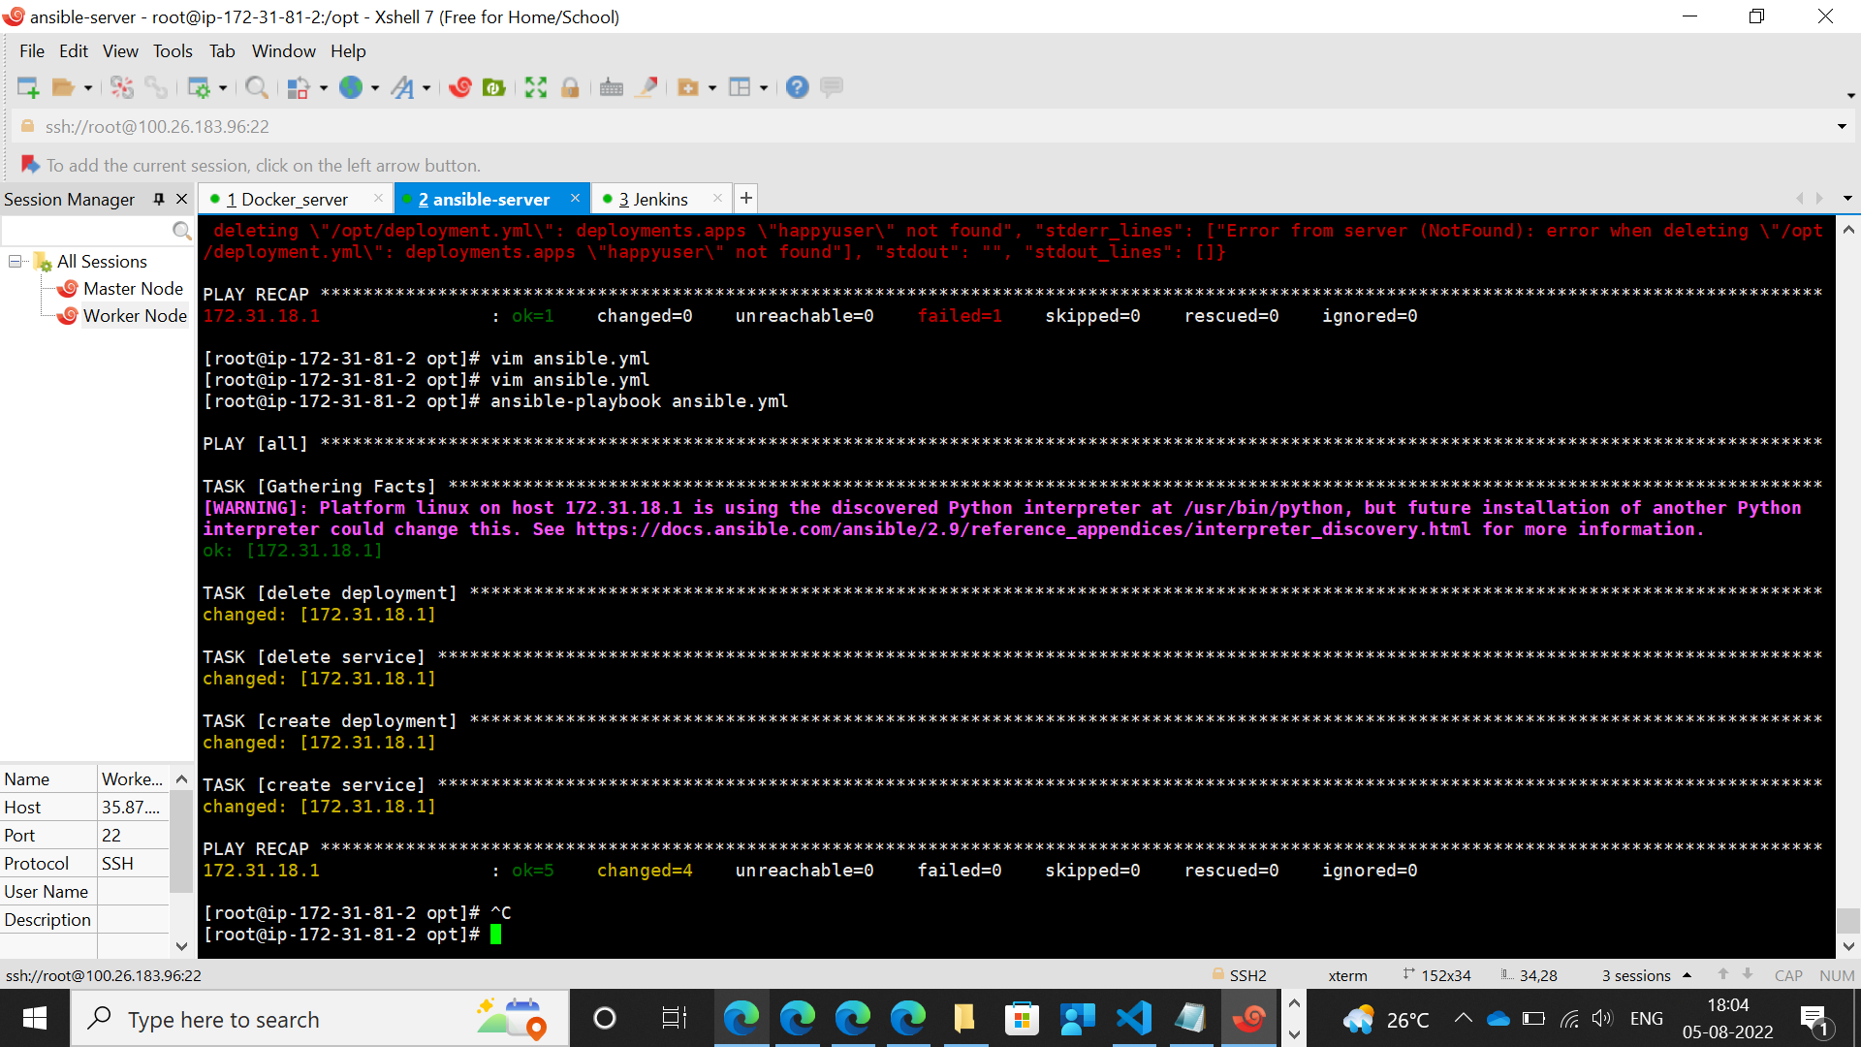

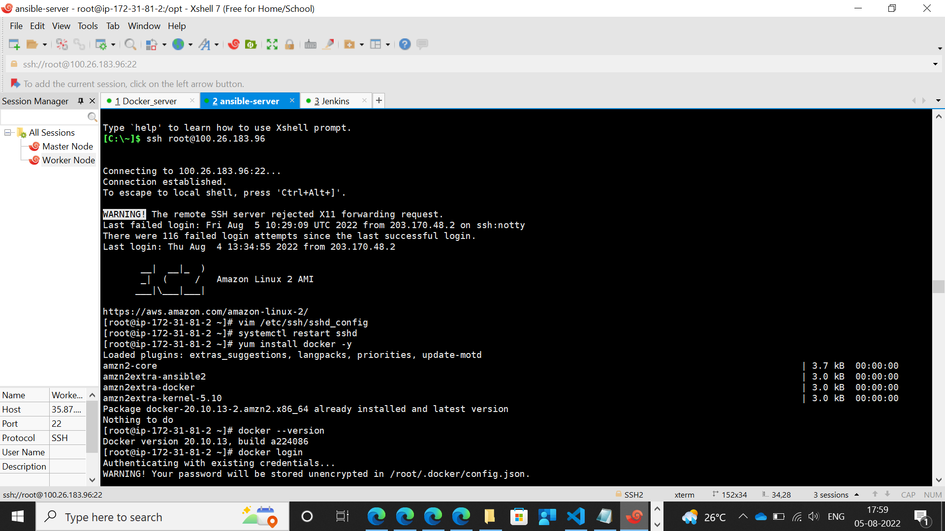

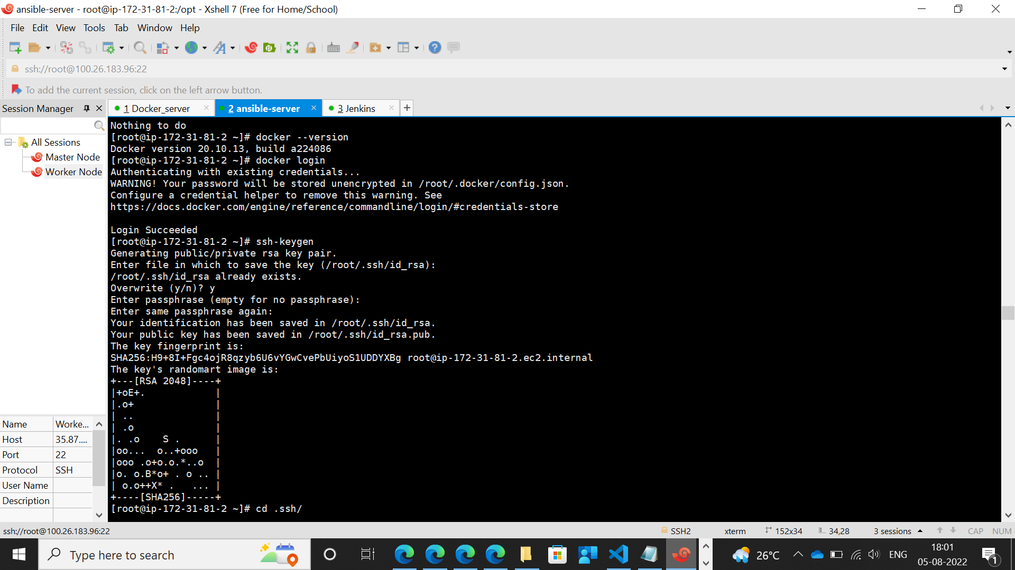

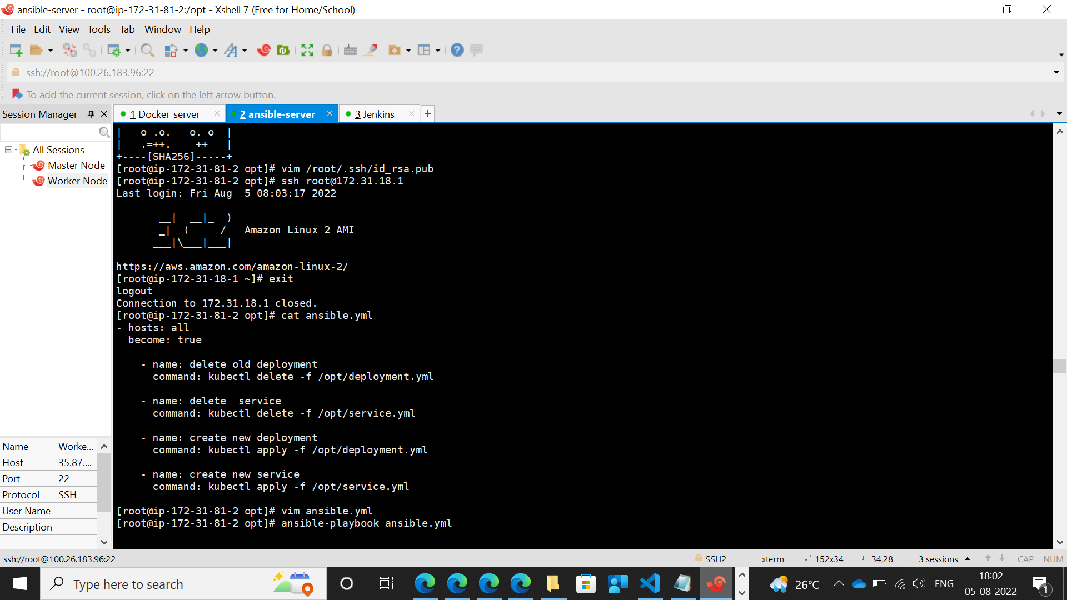

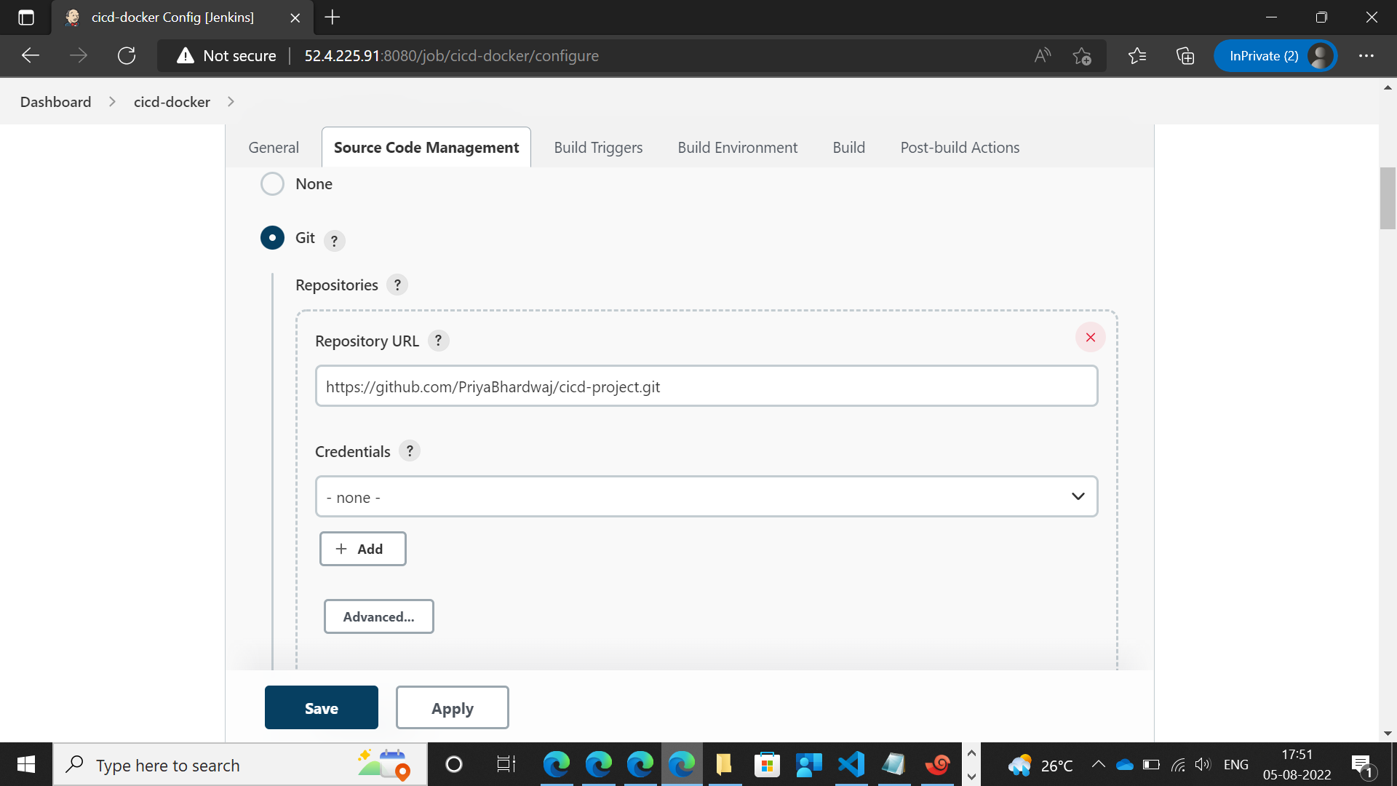

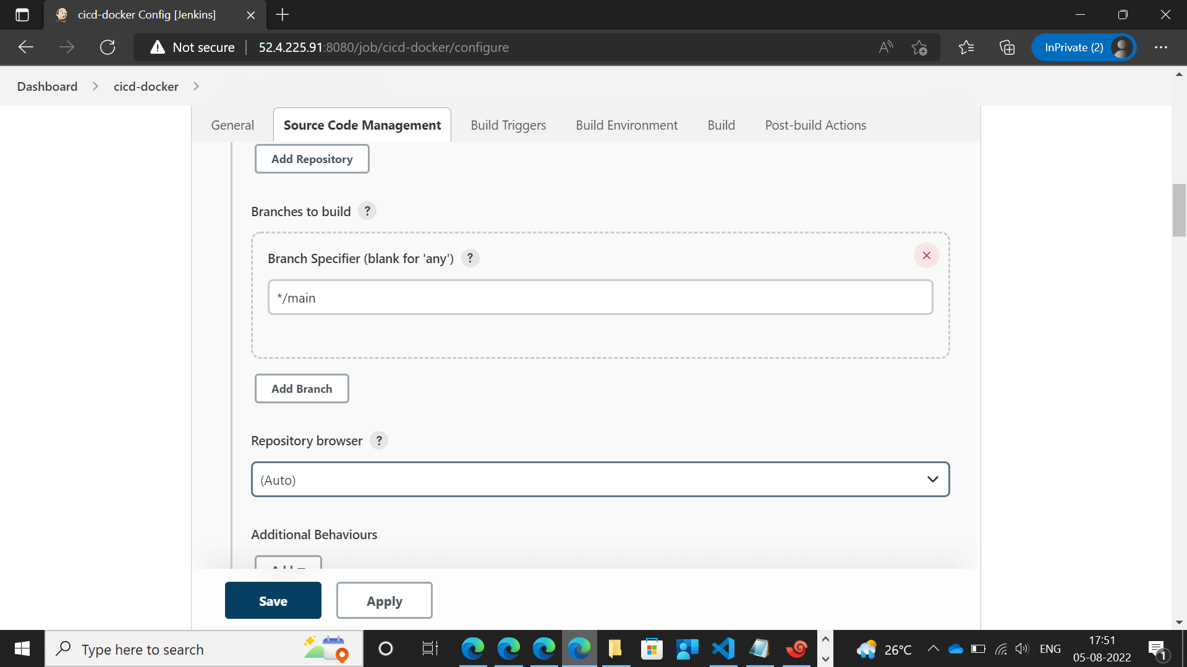

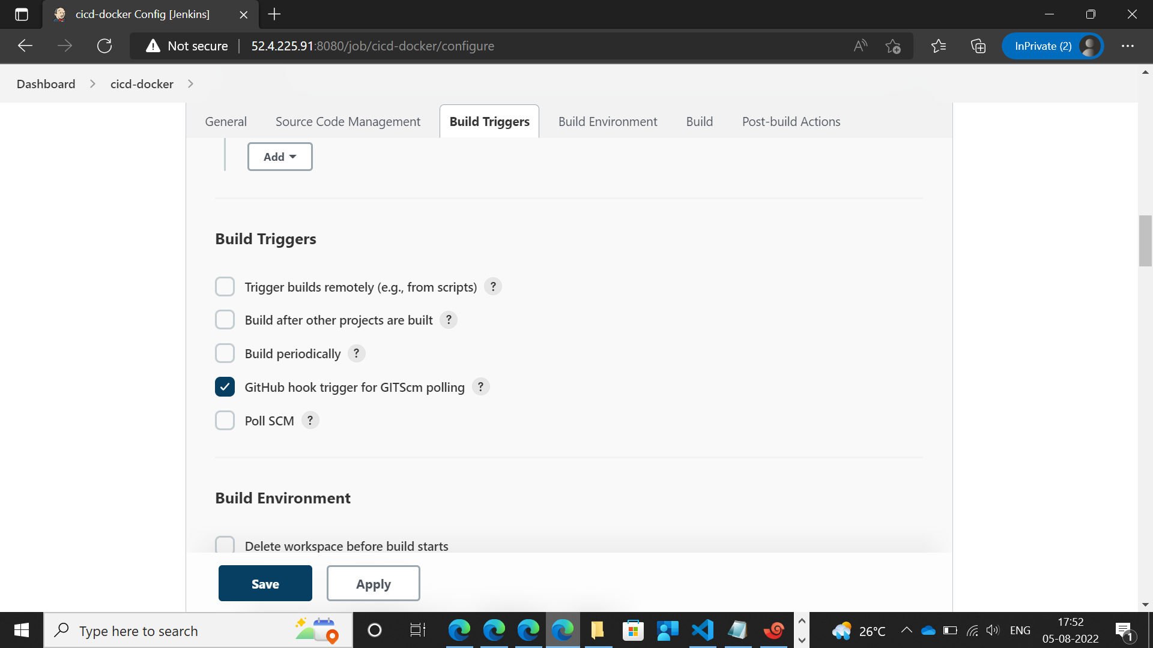

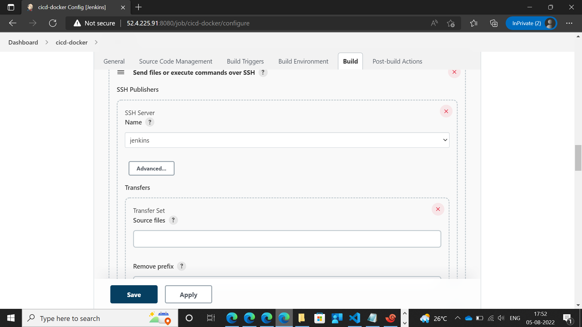

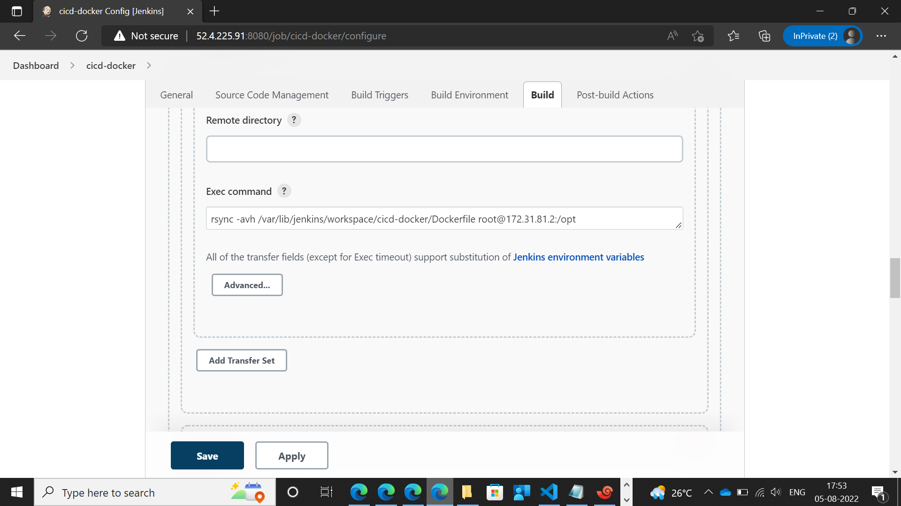

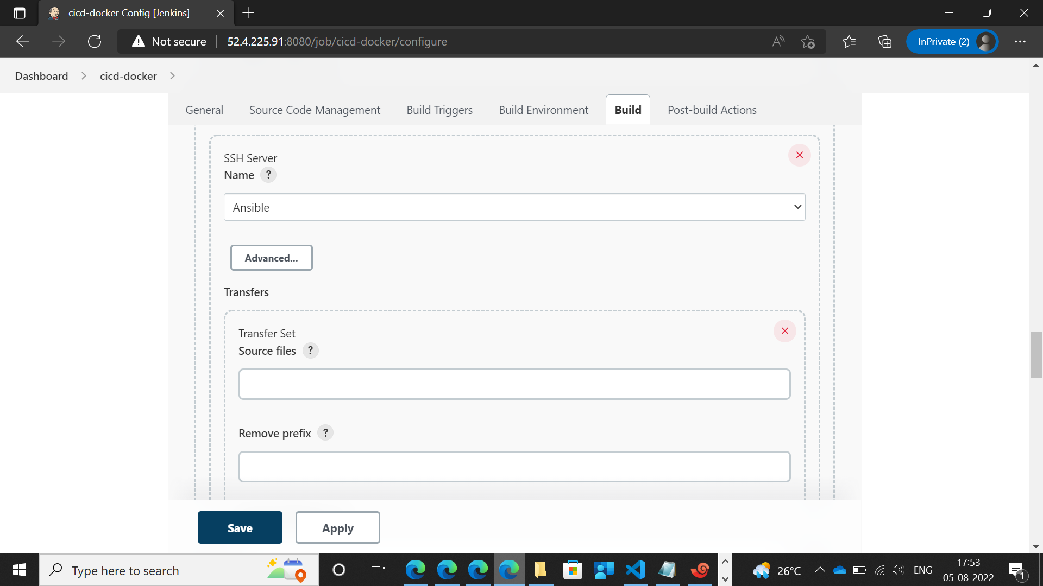

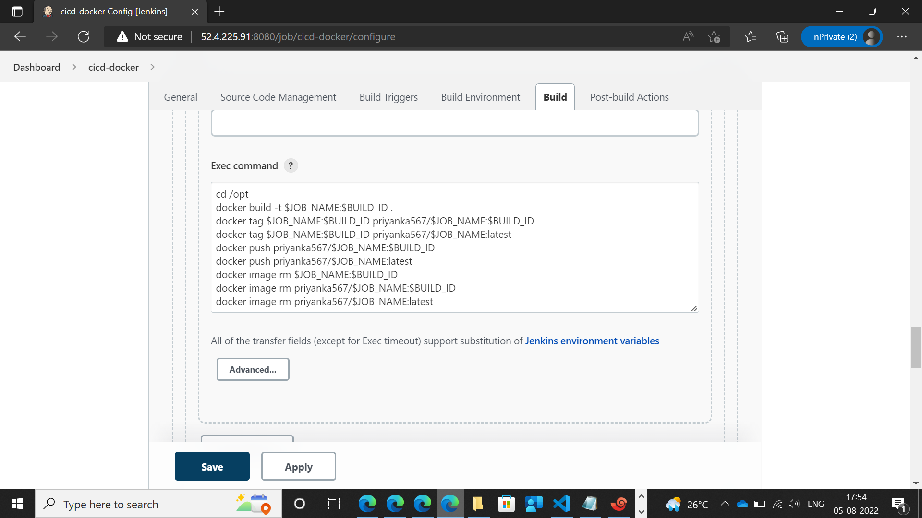

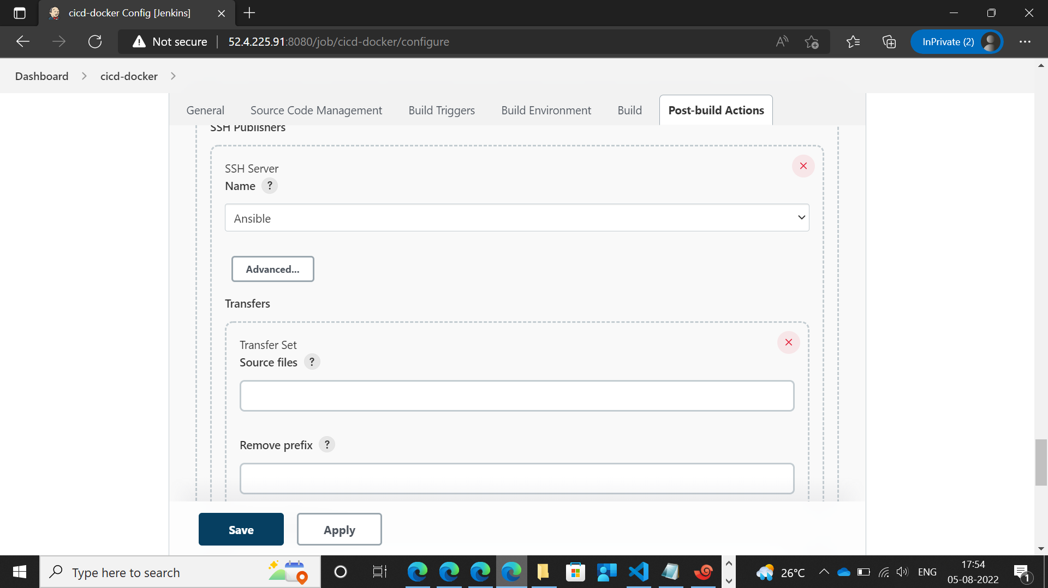

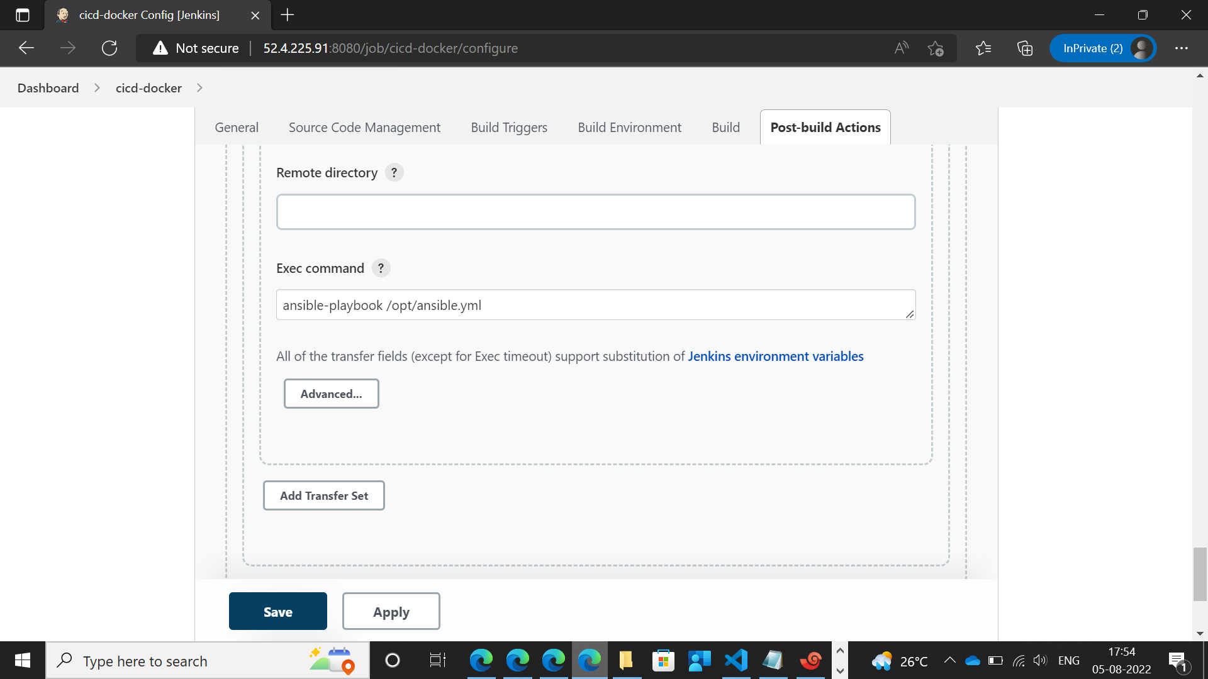

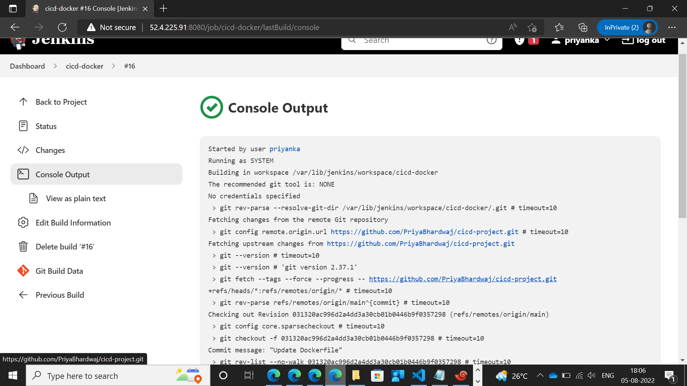

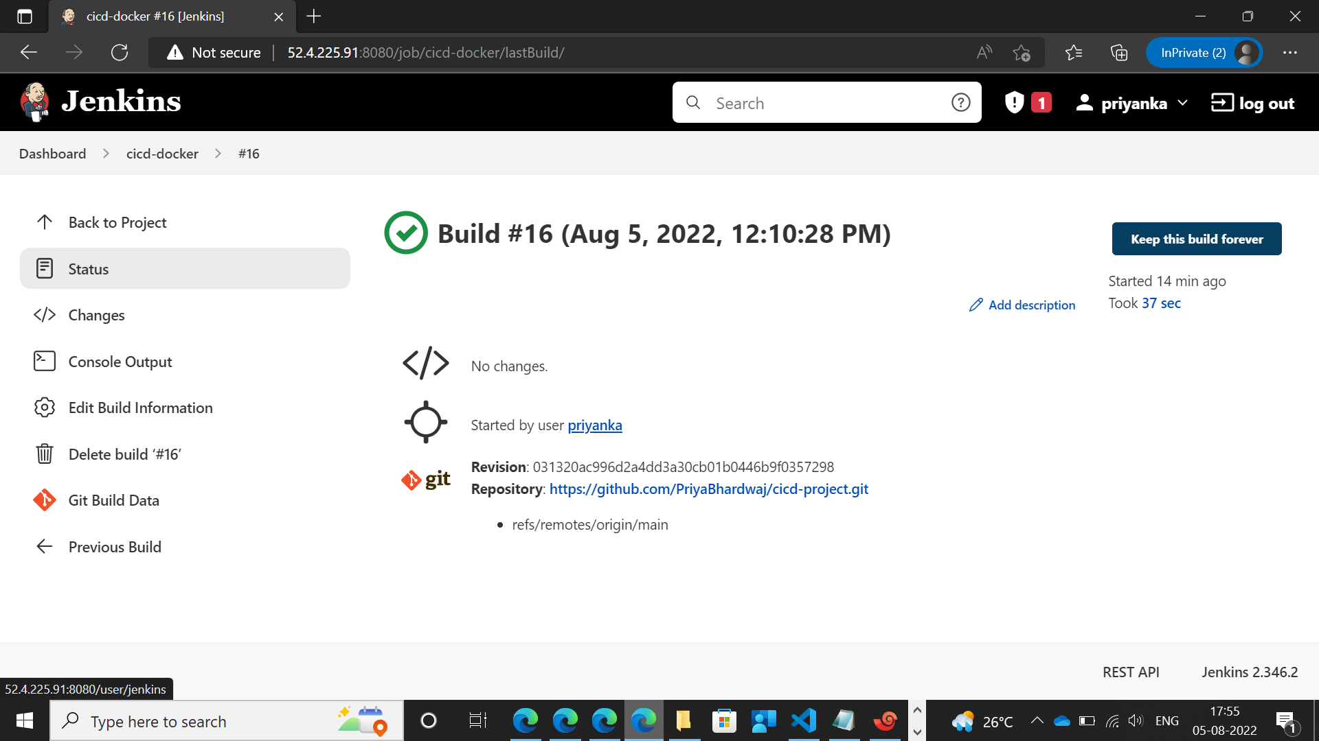

**Deployment.yml File**

apiVersion: apps/v1

kind: Deployment

metadata:

name: happyuser

spec:

selector:

matchLabels:

app: happyuser

replicas: 2

strategy:

**Service.Yml in Controller Node**

apiVersion: v1

kind: Service

metadata:

name: happyuser

spec:

selector:

app: happyuser

type: LoadBalancer

ports:

- port: 8080

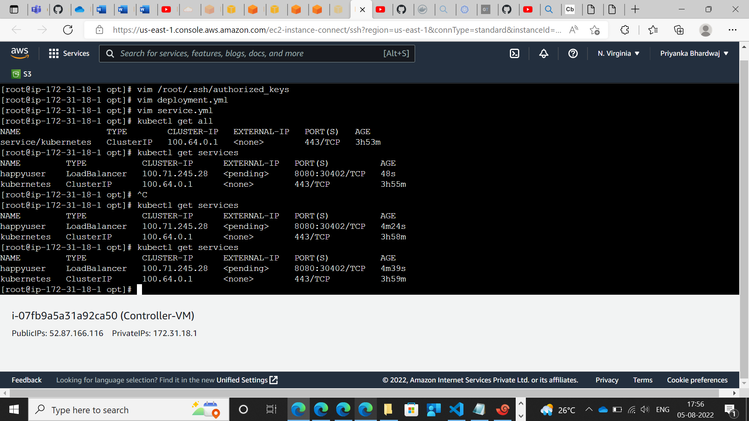

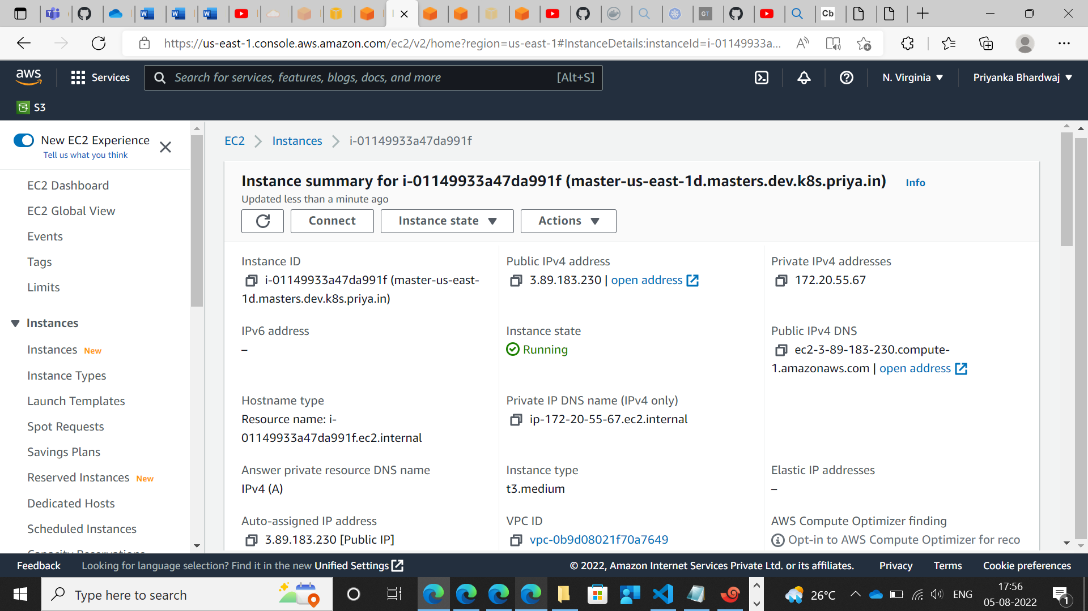

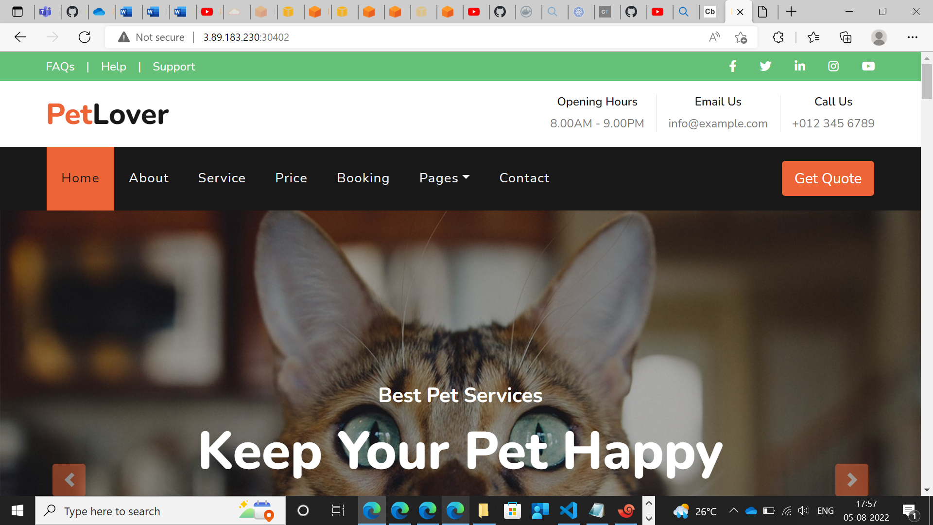

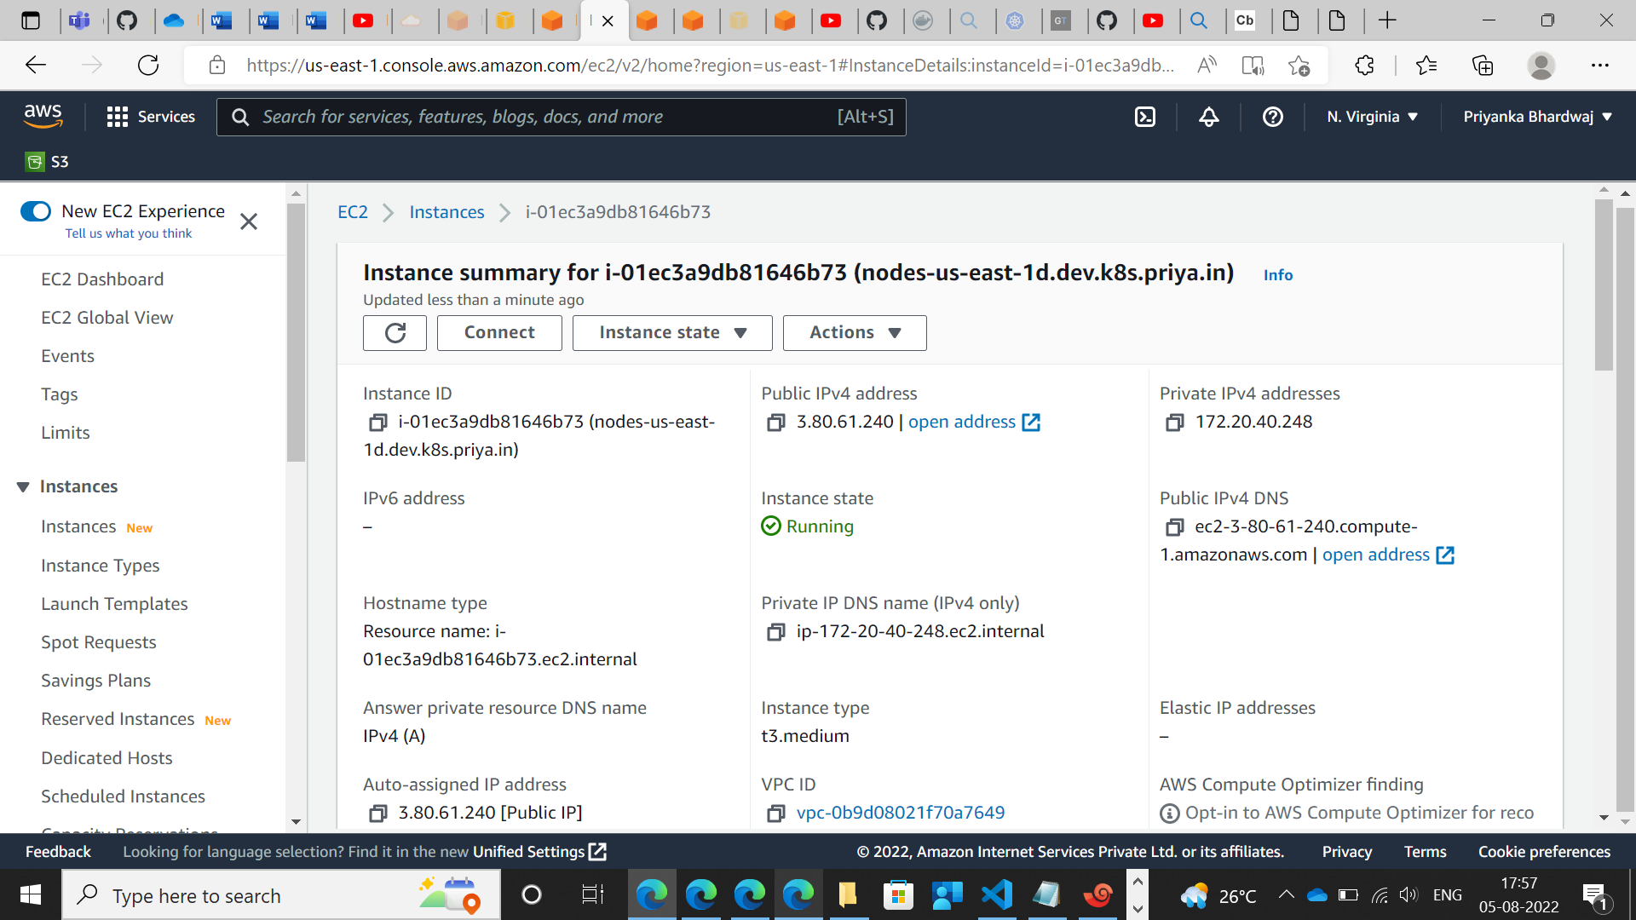

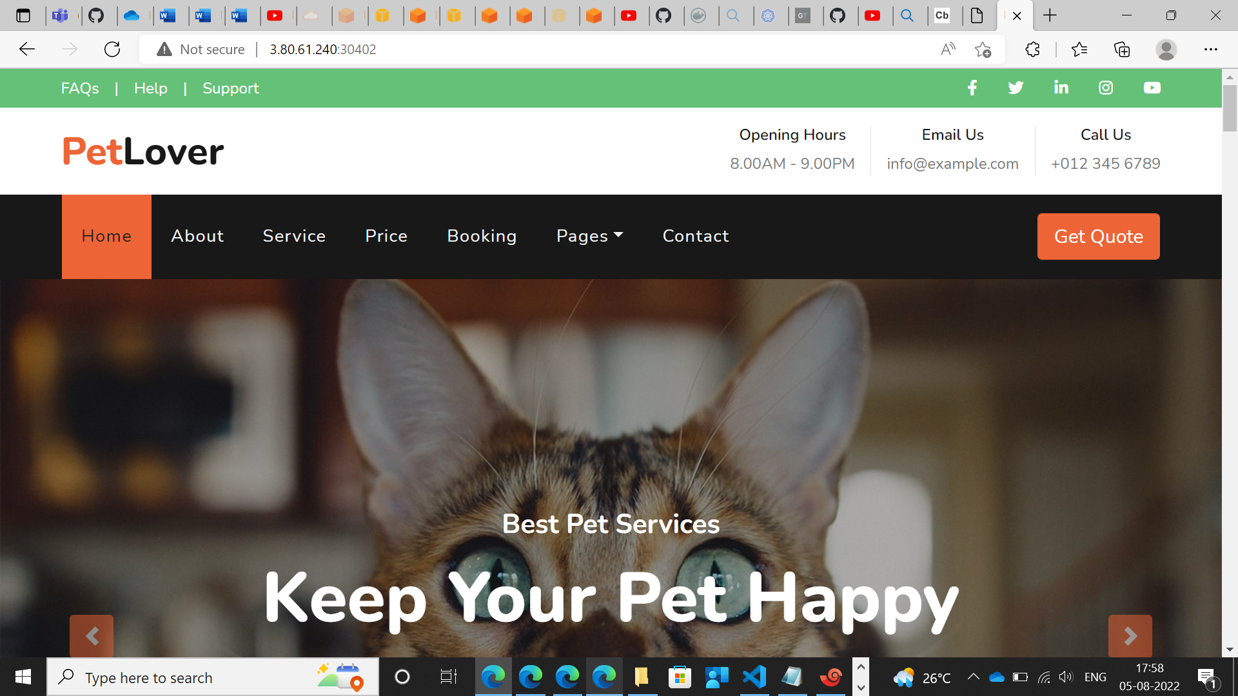

Ansible.yml

- hosts: all

become: true

- name: delete old deployment

command: kubectl delete -f /opt/deployment.yml

- name: delete service

command: kubectl delete -f /opt/service.yml

- name: create new deployment

command: kubectl apply -f /opt/deployment.yml

- name: create new service

command: kubectl apply -f /opt/service.yml